Hi ___,
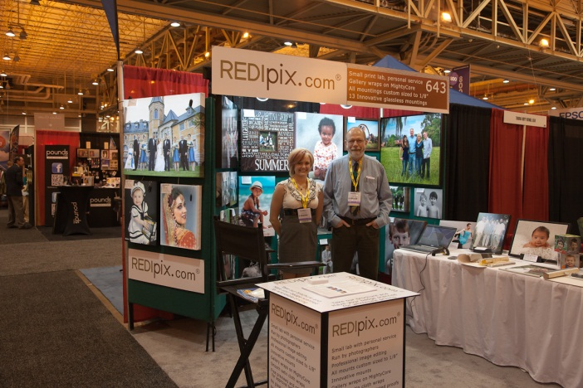
Thank you for visiting Redipix.com at Imaging USA! We hope you loved the unique products we offer to the professional photography community.
To get you started, we have created a wholesale account for you on Redipix.com with a 10% discount on all our products. Use the “Send password” link on the login page to receive your password. Then go to your account to find out about increasing your discount up to 30%.
What sets us apart from the other printing labs?
- Small lab with personal service. Our 800 number and email are answered by our professional staff 9 AM to 9 PM Eastern, 7 days a week.
- Any size print. Want a gallery wrap 23 3/8 x 33 5/8 x 2 1/4? You got it. Sizes range from 3x3 to 40x80 inches and up to 4 inches deep.
- Unique products you will find nowhere else (see below).
- Digital or printed proofs on every print, free of charge.
- Museum-quality materials. All products are designed to last a lifetime. Giclée pigment inks last up to 200 years.
- Replacement or money back if there are problems with your order, subject to our terms and conditions.
- Certificate of Authenticity customized for free with all prints. Includes copyright and place for you to sign.
- Six print media including two fine art all-cotton papers, smooth satin cloth, artist canvas, e-surface luster, and metallic. Request a free sample pack by reply email.
- Product samples at 50% off, limit one per mounting, any size. Use coupon code PROSAMPLE at checkout.
Our products that generated the most interest at the show are:
Gallery Wrap Elite: Built on super-tough MightyCore to last a lifetime under abuse. Canvas or smooth satin cloth. Hanging wire holds tight to the wall. Our flagship product for over 6 years.
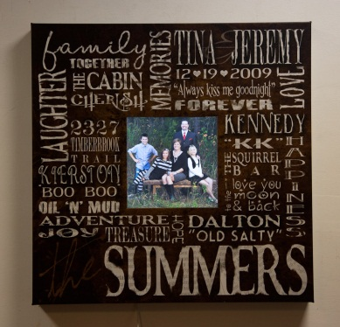
Gallery Wrap LED Dazzle: Backlit edge-to-edge with a remote-control dimmer. These have dazzled our customers for the past 2 years.
Gallery Wrap Shadowbox with custom word art and front-lit with LEDs. This is a brand-new product and not yet on our website. Contact us for prices and ordering.
Gallery Wrap Album: Hangs on the wall or sticks to a refrigerator when not open for viewing. Under development and should be in production within 1-2 months.
Other products
Rolled giclée unmounted prints | Box mount (standout) | Gallery wrap kit | Box mount kit | Flat mount | Metal floating wrap frame | Solid hardwood floating wrap frame | ArtRoll banners | Stretch-roll canvas wrap | Photo cube | Greeting/Note cards

